ProMesh

Business Plan

1339 Wellington St. W, Ottawa, ON

(647) 471 - 4201

promesh2019@gmail.com

Green House

19 July 2019

## 

## **Table of Contents**

1. **Executive Summary**
   * 1. Business Owners & Product/Service
     2. Mission Statement
     3. Company Structure
     4. Target Markets
     5. Current Opportunity
     6. Projection of Business Future
     7. Financial Summary
2. **Market Analysis**
   * 1. Market Exploration and Identification
     2. Industry Trends
     3. Demographics and Target Market
     4. Entry Barriers
3. **Marketing Strategy**
   * 1. Product/Service
     2. Sales Strategy
     3. Promotion
     4. Pricing Strategy
     5. Web Strategy
     6. Differentiation (Competitive Advantage)
4. **Operations Plan**
   * 1. Location
     2. Operation
     3. Organization Structure
     4. Employees
     5. Space
     6. Capacity
     7. Critical Suppliers
     8. Financial System
     9. Computer System
     10. Equipment
     11. Permits and Licenses
     12. Insurance
     13. Contracts
     14. Patents and Copyrights
     15. Credit Policy
5. **Financial Plan**
   * 1. Product and Service Pricing
     2. Funding Source(s)
     3. Cash Flow Projection (Appendix A)
6. **Appendix A:** Cash Flow Statement & Other Financial Statements
7. **Executive Summary**
8. **Business Owners & Product/Service**

ProMesh was founded by a group of self-driven and bright-minded high school students striving for change in Canada. With an abundance of experience in business, startup competitions, and exploring modern world issues, the business has created a solution for a prominent issue that Canadians face on a daily basis. As a startup company, ProMesh will be relying on investments as well as individual time and investments to run the company in the first years. The business owners will equally own 51% of the shares leaving 49% for investors. Please see Appendix C attached for business ownership specifics.

ProMesh is a company that aims to reduce single-use plastic bag waste through introducing and maintaining a system of reusable produce bags in grocery stores. ProMesh produce bags are durable and of far better quality compared to the standard plastic produce bag. The bag will be tared and includes smart features such as an RFID chip. The consumers pay a deposit fee for using and taking the mesh bag home. Once the bag is brought back, it will be collected and the deposit fee will be refunded.

1. **Mission Statement**

The primary focus of ProMesh is to reduce plastic waste that is used in grocery stores, starting with their plastic produce bags. As a service company, ProMesh aims to work alongside grocery stores in an attempt to make produce shopping more convenient for both the store and their customers while simultaneously reducing our ecological footprint.

1. **Company Structure**

As a start-up company, every owner will be working on a Board of Directors to manage the day-to-day operations of the business. In total, there are ten directors on the Board with six departments: Marketing, Finance, Production, Design and Communications. These departments will work closely with partnered supermarkets to ensure that the service is efficient and convenient. Promesh will follow a general partnership model, as every owner will be working, investing and liable for the shares of the company. Firstly, the business will partner with local grocery stores and then expand towards partnerships with larger grocery chains in the future.

1. **Target Markets**

Since ProMesh revolves around a business to business service, the initial target market will be local grocery stores that strive to take the next step towards eliminating plastic produce waste. The indirect target will include consumers that shop at these grocery stores, as they will be the primary contributors in reducing plastic produce waste in the service. The target market will be located in Ottawa. Promesh will focus on this geographic location in the startup phase. This is due to the large number of smaller grocery stores located in Ottawa relative to other major cities in Canada.

1. **Current Opportunity**

There is currently a large opportunity for reducing packaging waste in Canada due to many reasons. Firstly, society is trying to steer away from single use packaging, especially in Canada. A majority of Canadians support a ban on single-use plastics, which includes the plastic produce bags that ProMesh is aiming to reduce . In a recent poll done by Nanos Research, 56% of Canadians support a total ban on single-use plastics, and 25% somewhat support a ban (Dickson, 2019). This means that the majority of Canadians will be willing to take alternate measures if a total ban is put into place in 2021, therefore providing an opportunity for a convenient solution such as ProMesh to be implemented. The legislature for this ban is already on its way, and has become a national issue in the past few years, following the similar actions taken by the European Union. A permanent ban for these single use plastics is entirely feasible, which will provide a large opportunity for reusable produce bags. As such, ProMes offers both convenience and the opportunity to reducing plastic waste at the same time.

Lastly, the service is very unique, as there are no current companies who offer a similar service. Promesh offers a relatively convenient method for consumers to reduce their plastic waste. Currently, consumers have to purchase their own produce bags and bring them every time to the grocery store to store the produce they purchase, and also have to clean the bags when they get dirty. With the introduction of the new service, consumers do not have to go through the trouble of using, cleaning, and potentially forgetting their own bags because we will provide them with high-quality mesh bags at their convenience. The consumers will be able to get their full deposit back when they return ProMesh bags. There is also an incentive for consumers to keep the bags and use them for other purposes, as the mesh bag is very versatile and can be useful for things like storing household objects.

1. **Projection of Business Future**

The future of the business is very bright as there is a positive outlook on environmentally friendly products. In addition, a popular trend these days is environmentally-friendly products and services. Starting this service at this moment will ensure that when grocery stores are forced to switch to reusable bags, we will have an established brand and a service that these grocery stores can look to partner with. ProMesh also has a convenient operating structure, which means when grocery stores are searching for replacements of plastic produce bags, a contract can be discussed easily and ProMesh bags will be in service relatively fast when compared to other alternatives. The opportunity for growth is relatively timeless, as reducing plastic waste will not be an instant fix. Rather, it will be a process and ProMesh can take advantage of this by expanding our service at this critical window. At this point, if competitors were to enter the market, ProMesh would already have a majority of the market share, and it would be difficult for grocery stores to choose other businesses over ProMesh, as the business has already been operational for multiple years.

1. **Financial Summary**

To launch the startup, ProMesh will seek a $100,000 loan, which will be paid-off over the course of 2 years. The total estimated costs of the startup is estimated at $250,000. Due to predicted expansion and growth of the venture, the total amount of projected average monthly expenses changes over the course of the three year plan; in year one expenses will be $20,000 per month; entering year 2, this will increase to $30,000 per month; in year 3, expenses are predicted at $70,000. During the first year of ProMesh service, no net income will be made, as large material, service costs and capital expenditure will need to be covered as the business undergoes startup. In year two, the total amount of projected average monthly income will be at $6,000, with sharp increases at 6 months intervals to weigh the end of contracts and added revenue due to failure rate of return of ProMesh bags; these 6 months intervals rise to an average monthly revenue of $23,000. Lastly, the predicted 3rd year average monthly revenue will be $54,100, once again with sharp increases at 6 month intervals to $123,500. This is also in part due to economies of scale, as ProMesh grows as a company.

1. **Market Analysis**
2. **Market Exploration and Identification**

Given the company's mission of reducing plastic waste in Canada, ProMesh’s market will be environmentally conscious superstores and consumers in Canada. Furthermore, despite consumers having no net explicit costs for using ProMesh bags, the business model would require consumers to have extra liquid cash on hand when buying groceries. As a result, the specific market segment should be pro-environmental superstores and, ultimately, consumers that have a stable supply of some extra cash.

Upon analysis of the industry of reusable products, ProMesh found that there are no other companies that are dependent on a similar business model, and many of the current solutions to single-use plastics do not implement a closed-loop system. There are many changes in the past few years towards eliminating waste. There have been mandatory fees - implemented across the country - charged at supermarkets for purchasing single-use plastic bags. Moreover, the federal government is looking towards banning single-use plastics as early as 2021. Add the fact that 56% of Canadians support and 25% of Canadians somewhat support a ban on single-use plastics, we find ourselves in a potentially rapidly growing market. Because ProMesh operates a completely different model compared to the competition, ProMesh has a lot of potential in the reusable food packaging industry.¹

1. **Industry Trends**

The service that ProMesh provides falls under the grocery food packaging and bagging industry. Specifically, it works perfectly in unison with bulk food stores across the country as well as environmentally conscious smaller grocery chains such as “Herbs and Spice”. Bulk foods were introduced in their current form in 2010 before becoming somewhat popularized in the Americas. Today, 3 billion kilograms of single-use plastic bags are tossed out each year. Many of these plastic bags take nearly half a thousand years to decompose. There has been a push towards the use of reusable bags and experts predict a growing trend of reusable bags in grocery stores now with the pressing issue of a single-use plastic ban across the country. ²

1. **Demographics & Target Market**

ProMesh set up a general survey of Shads and their close friends on several related subjects such as how often they opt to use reusable bags. The survey resulted in a total of 100 participants. 65 stated that they did use reusable bags and 14 said no, with 21 saying sometimes, depending on which items they set out to purchase. Generally, even those who often use reusable bags do not carry them on trips in which they do not expect to purchase in bulk, and therefore will not use them for spontaneous trips. Others stated that they keep in mind if a store charges for plastic bags, and will use reusable bags if they would be charged for plastic ones. Those who used reusable bags spoke of their general utility and ease-of-use, partially because they are more comfortable than plastic bags for heavier loads.

If reusable bags were more accessible, 90 stated they would use them regularly and 75 would be willing to pay extra for reusable bags, if they would be able to return them for money back. Generally, the greatest complaint was that consumers who visited different grocers regularly wouldn’t know if they would return to the store. On the topic of deposit amount, our brackets were very evenly distributed. <$0.05, $0.1 - $0.2, $0.2 - $0.5, and $0.5 - $1 all received around 20% willingness from participants as the maximum they would pay. When asked to rate from 1 to 5 how much they cared for Convenience, Eco-Friendliness, and Cost respectively, convenience and eco-friendliness tied for highest rating, while cost trailed behind. This suggests the demographics of those polled is likely middle class to lower upper class.

Our market share is not necessarily meant to appeal to businesses that have a very high percentage of reusable bag usage, more to those who forget to bring reusable bags or for other reasons do not use them. Many of those polled admitted to regularly forgetting to bring their purchased bags to the store, which would be easily fixed by the inclusion of a deposit as our system has.

1. **Entry Barriers**

Barriers of entry will mainly be around the relationships with grocery stores. As the business is starting this service with little or even no competition, the business will be able to build brand relationships with the clientele. Other entry barriers include startup costs (while not very costly, they are still there). Barriers to entry can be defined as fixed costs that need to be incurred by a new business into a market that is independent of production or sales. In this specific market, start up costs are relatively low, however the main barrier of entry will be the relationships that ProMesh, as one of the first businesses in the market, will have with grocery stores.

1. **Marketing Strategy**
2. ProMesh provides a convenient and efficient packaging system that is easy to clean and reuse. Contrary to other companies that only sell reusable produce bags, we provide a sanitizing and refund system that allows customers to get their deposit back once they bring the bag back for reuse. The customer is able to receive clean and durable bags every time they enter the supermarket. ProMesh is liable for all debts and damages related to the service providing no disadvantage for the customers.

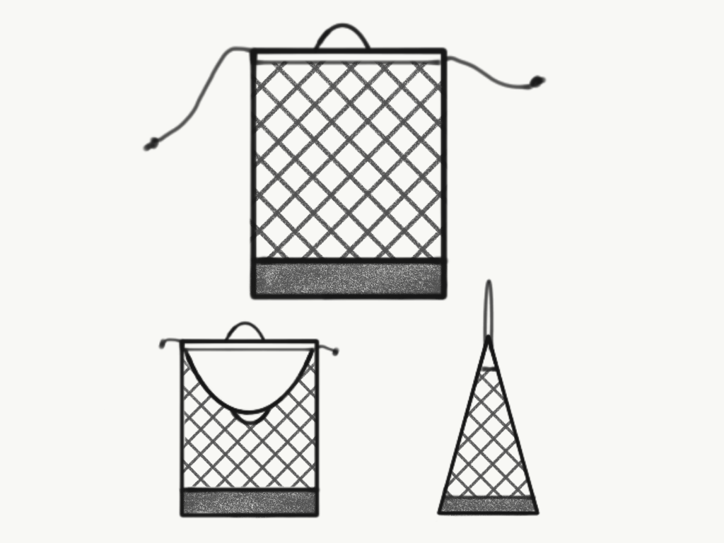

1. **Product/Service**

The original ProMesh bag has dimensions of 30cm by 43cm. This size is a general medium sized bag that will be perfect for general produce such as apples, cucumbers or other produce. The ProMesh bag is made from recycled PET plastic (rPET). Water bottles use PET plastic, thus recycling this material will reduce waste. The mesh, the structured bottom, the handle and the drawstring will all be made from recycled PET plastic so that the teardown, sanitization and reusability of the material will be optimized. The ProMesh bag includes two drawstrings on either side of the bag, each 0.2cm wide to easily be able to cover and protect the produce inside the bag. To reduce the amount of plastic waste, our drawstrings will not have toggles for easy manufacturing. Each bag uses roughly 46 centimeters of rPET. On either side of the ProMesh bag, there are small rPET handles, each 1-1.5cm wide that can be brought together for easy mobility or one can be hung up on a hook to easily access the produce. The rPET handles will also enable people with disabilities to easily be able to hang their ProMesh bag on to the side of their wheelchair. These handles will also be used for sanitization after use as they can be easily thrown into the washing machine that will be provided to the supermarket by ProMesh. These handles will be durable and convenient for easy use and efficiency. Finally, we are including an RFID tag on the bottom of the bag for easy inventory tracking. This tag will also allow for more automation during checkout and lower overall labour costs for supermarkets. All of these product features will create a convenient and efficient system for consumers.

Below is a general overview of the ProMesh service:

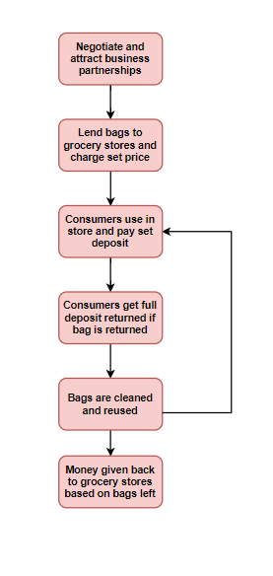

1. **Sales Strategy**

The sales strategy revolves around providing ProMesh bags to the grocery stores that we partner with, which then are paid for by customers. ProMesh will not be selling the mesh bags to retailers, essentially our “retailers” are the grocery stores, which are then “resold” to the customers.

1. **Promotion**

ProMesh specifically targets pro-environment grocery stores, and, in turn, therefore, also targeting middle class to upper class pro-environment. As such, the interests of ProMesh and their primary consumers, grocery stores, are very much aligned. As a result, there is potential for partnership and mutual promotion when signing contracts with many of these grocery stores. To exemplify, ProMesh bags will bear the ProMesh logo, and when grocery stores run advertisements about their new environmentally friendly packaging policies, ProMesh will also share the publicity.

ProMesh will primarily also be reliant on word of mouth advertising in order to raise awareness about its product. This may include activities such as kickstarting hashtag phenomenons online to increase awareness about the brand as well as created animated videos to post on the ProMesh Instagram and Facebook page which can be shared free of cost. Nevertheless, because ProMesh’s primary consumers will be grocery stores, it is also likely beneficial to mail samples of ProMesh bags as well as present statistics through targeted direct mail flyers in order to generate interest in the product.

Obviously, as ProMesh develops and grows in size, more large scale and expensive promotion techniques will be used in order to manipulate market perception of our brand as well as our competitors.

1. **Pricing Strategy**

ProMesh’s pricing model for its services is based on the cost-plus pricing strategy: we charge a monthly service fee of $1250, and price the deposits for our mesh bags based on operation costs as well as the cost to produce the bags respectively, which was deduced as $0.80 per bag. At the beginning of our contract, grocery stores will pay $1.25 each for implementation of ProMesh bags, with each store beginning with 1,000 bags. At the end of the contract, ProMesh offers to buy back ProMesh bags from consumers, with the value of bags returned being reimbursed to the grocery store.

Over the course of the contract, grocery store users will pay a deposit of $1.25 to use ProMesh produce bags in transporting their produce to households. On the return of ProMesh bags, grocery store users receive their $1.25 deposit back. For bags unreturned, our company will receive double the revenue of each bag, both the $1.25 uncollected deposit from grocery store users and the $1.25 from grocery stores for unaccounted bags.

One of the disadvantages of the cost-plus pricing model is it’s shortfalls in accounting for factors such as competitor pricing. However, as ProMesh has the advantage of both timing in the rise of sustainable thinking, and in being the only business looking into this model in the first few years. Thus, the cost-plus pricing is the most effective method for us to employ.

1. **Web Strategy**

As a company, ProMesh would use their website to educate consumers on the effects of plastic waste in our environment, telling viewers about how the product can eliminate the damage caused by plastic bags. The company could touch on all parts like how plastic waste hurts animals, humans, the environment and how there is no getting rid of it, the only way to completely destroy it is through burning it and burning plastic harms the atmosphere. They could also say how even if it says its recyclable, it does not mean its being reused, most recycled materials are not used again and just crushed into big cubes and then stored until a company buys it.

1. **Differentiation**

Perhaps one of the most well known pieces of business literature is *Blue Ocean Strategy* written by professors W. Chan Kim and Renée Mauborgne. They explain the method to develop a product suited towards “blue ocean” markets making competition - “red ocean” markets - irrelevant. Upon analysis of ProMesh’s mesh bag product - observing the strategy canvas below - we find that the RFID equipped mesh bag exhibits many strengths that allow it succeed. First, we find that RFID equipped mesh bags exhibit focus. ProMesh has notable differences in terms of benefits it brings. An environmental focus and integration of smart technology allow feasible and easier marketing practices of the mesh bag products. The divergence in the positive benefits that ProMesh brings allows for a marketing plan to be developed that amplifies strengths and diminishes weaknesses. Upon analysis of the competitors in the same overarching industry as us, it can be observed that ProMesh bags bring different benefits compared to many other products. As a result, ProMesh are able to suit a specific market compared to other businesses.

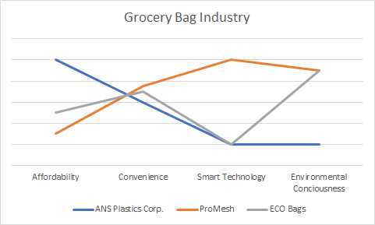

1. **Operations Plan**
2. **Location**

Our business will be focused in the Ottawa region, with the initial office space located at 1339 Wellington St. W, Ottawa, ON. This is due to the grocery store landscape, as there are many smaller, environmentally conscious grocery stores located in this region, which defines our target market. Ottawa is also a cheaper

1. **Operation**

Our business plans on starting to consult with grocery stores as early as August 1st, 2019. In this initial phase, costs will be low as we will be primarily meeting with our target market and promoting our service to them. Once enough interest is generated, we will begin production of our product and our business will officially start operating, and this can take place as early as September, 2019.

1. **Organization Structure**

(See Executive Summary Section 3)

1. **Employees**

Along with the Board of Directors, there will be three main employees we will be hiring for managerial responsibilities, the President, CFO, and Marketing VP. The President will have the most responsibility out of the three, overlooking operations and reporting a monthly overview to the Board of Directors outlining the operations and successes of ProMesh. Other responsibilities will be to overlook the CFO and Marketing VP, and make sure operations are running smoothly. The CFO (Chief Financial Officer) will overlook all financial operations, including cash flow statements and budgeting, and the Marketing VP will overlook all marketing operations, most importantly sales and promotion. These employees will ideally be employed at another location and looking for new leadership opportunities. During the first year, the job will be part time, and as ProMesh grows as a business, these positions will be converted to a full time position to overlook the expansion of the business.

1. **Space**

In the initial startup phase, space for production will not be needed as we will be outsourcing the production of our ProMesh bags to another producer. The simple reason for this is due to production costs, and in the initial phase, we are just trying to expand our business as much as possible and producing our own bags will be too expensive. However, if we reach a point where our revenue can sustain our own production, investing in our own production facility can be entirely feasible and is something worth considering since it will reduce costs related to transportation of our mesh bags.

In terms of space for our employees, we will be investing in a smaller office space for our employees due to the limited number of employees we will have during the startup phase. The space, as mentioned earlier, will be located at 1339 Wellington St. W, Ottawa, ON ³. This is a 1,000 ft2 office space with two private office spaces and plenty of open space for more employees. The rent cost will be $1,000 per month, which equates to around $12.00/sf/yr. This office space will be optimal for the startup phase of the business as it is a relatively cheap office space which provides the basic functions for the operations of ProMesh.

1. **Capacity**

In our first year, we will be aiming for a minimum of 5 grocery stores to use our service, and ideally up to 10. The reason we can provide this capacity is due to the simple nature of our service. These mesh bags, while very durable, are relatively cheap and easy to produce in large quantities. This means we can constantly supply our bags to our clients at a fast rate, and therefore are able to provide our service to up to 10 grocery stores. Another aspect which allows us to have this capacity is that our operations are fairly limited. Our main operation is shipping our bags to each of these stores. We will be supplying a washing machine for these bags that customers bring back, and there is no complicated process which requires employees or machinery. Therefore, we can streamline our process and provide our service to many clients at the same time.

1. **Critical Suppliers**

As a startup, ProMesh will try and minimize costs in the initial phase, meaning that the expenses related to producing the mesh bags will be too expensive for ProMesh to support in the first year. The result of this is a partnership with a reliable, high-quality plastic mesh bag producer. After many discussions, a partnership was reached with Henan Fengcheng Plastic Co., Ltd. which will allow for the production of the ProMesh bags. Specializing in plastic knitted products, the company has been operating since 2008 and has a total annual revenue of $5 million - $10 million USD. Working with this reliable producer ensures product quality, and allows ProMesh to add product features, such as RFID tags and other special features.

1. **Financial and Computer System**

For the financial system, the CFO will be the primary person overlooking the finances of ProMesh, including cash flow statements and other financial responsibilities. ProMesh will not be using an expensive computer system, communication will be mainly through email and Monday.com. Monday.com is a productivity software that allows employees to communicate meetings and important information efficiently while managing deadlines all on one software. Using this cheap technology, communication among employees will be efficient and other expensive alternatives will not be needed.

1. **Equipment**

The required equipment consists of:

Fabric, mesh and draw-strings made from recycled PET (rPET)

General industrial sewing materials

RFID tag/relevant technology

A metric spring scale for testing effective carrying capacity of bags

Washing machine to sanitize the bags after return

For ProMesh offices, equipment needed also includes desks, chairs, computers, printers/fax machines, which is accounted for in capital expenditures.

1. **Insurance**

For employee benefits, ProMesh will have a small business insurance policy of $50 per month. In terms of business insurance, ProMesh will be combining general liability and commercial property coverage into a BOP bundle, which we can purchase at a lower rate when combined. Companies such as ZenInsurance and TruShieldInsurance can offer these small business insurance packages, which are estimated to be around $600 per year.

1. **Contracts**

The main contracts that ProMesh will have is with the grocery stores that want our service, as a minimum 6 month contract will be required for our service to be provided to the grocery stores. The contract will detail the payment process, which will be monthly increments, and other details including the supply of ProMesh bags and the details on how the collection of bags will work.

1. **Patents and Copyrights**

No structures in our bag models are patentable, and neither is our business model. We require a trademark on the ProMesh brand name.

1. **Financial Plan**
2. **Product and Service Pricing**

We charge a monthly service fee of $1250, and price the deposits for the mesh bags based on operation costs as well as the cost to produce the bags respectively, $0.80 per bag. With each store beginning with an average of 1,000 ProMesh bags, grocery stores will pay $1.25 each for implementation of ProMesh bags. At the end of the contract, ProMesh offers to buy back ProMesh bags from consumers, with the value of bags returned being reimbursed to the grocery store.

Grocery store users pay a deposit of $1.25 to use ProMesh produce bags in lieu of single-use produce bags, which is used to transport produce from grocery stores to households. When grocery store users return their ProMesh bags, grocery store users receive their $1.25 deposit back. For bags unreturned, our company will receive double the revenue of each bag, both the $1.25 uncollected deposit from grocery store users and the $1.25 from grocery stores for unaccounted bags.

1. **Funding Source(s)**

Due to the size of our startup, it was deduced that large grants would not be an option in covering our costs. Instead, ProMesh will apply for a long-term loan from various banks to cover debt costs in the first year, equal to $100,000, which will be paid-off throughout year one and two. This along with a start up investment of $150,000 from the owners and investors will allow us to acquire the necessary assets.

1. **Cash Flow Projection**

See Appendix A

## **Appendix A**

|  |  |  |  |
| --- | --- | --- | --- |
| **ProMesh** |  |  |  |
| Income Statement | **Year 1** | **Year 2** | **Year 3** |
|  |  |  |  |
| Sales | $161,900.00 | $574,120.00 | $1,961,610.00 |
| Cost of Goods Sold | $0.00 | $0.00 | $0.00 |
| Gross Margin | $161,900.00 | $574,120.00 | $1,961,610.00 |
|  |  |  |  |
| Operating Expenses |  |  |  |
| - Advertising & Promotion | $24,000.00 | $48,000.00 | $60,000.00 |
| - Salaries & Fringe Benefits | $136,500.00 | $241,500.00 | $472,500.00 |
| - Wages | $14,940.00 | $53,037.00 | $177,786.00 |
| - Depreciation | $18,987.27 | $51,993.80 | $112,302.55 |
| Other Expenses | $1,200.00 | $3,600.00 | $7,200.00 |
| Utilities | $2,400.00 | $4,200.00 | $8,400.00 |
| Telephone | $540.00 | $540.00 | $1,080.00 |
| Cleaning | $600.00 | $2,040.00 | $7,200.00 |
| Insurance | $600.00 | $600.00 | $960.00 |
| Rent | $14,400.00 | $14,400.00 | $43,200.00 |
|  | $0.00 | $0.00 | $0.00 |
|  | $0.00 | $0.00 | $0.00 |
|  | $0.00 | $0.00 | $0.00 |
|  | $0.00 | $0.00 | $0.00 |
|  | $0.00 | $0.00 | $0.00 |
| Total Operating Expenses | $214,167.27 | $419,910.80 | $890,628.55 |
|  |  |  |  |
| Operating Profit | -$52,267.27 | $154,209.20 | $1,070,981.45 |
|  |  |  |  |
| Non Operating Income/Expenses |  |  |  |
| - Interest Expense | $4,680.55 | $8,709.74 | $15,400.82 |
| Profit Before Taxes | -$56,947.82 | $145,499.46 | $1,055,580.62 |
| Income Taxes | -$14,236.95 | $36,374.87 | $263,895.16 |
| Net Income | -$42,710.86 | $109,124.60 | $791,685.47 |

|  |  |  |  |
| --- | --- | --- | --- |
| **ProMesh** |  |  |  |
| **Balance Sheet** | **Year 1** | **Year 2** | **Year 3** |
|  | **Month 12** | **Month 12** | **Month 12** |
| **Assets** |  |  |  |
| **Current Assets** |  |  |  |
| **- Cash** | $61,232.77 | $86,209.61 | $947,142.83 |
| **- Accounts Receivable** | $5,602.50 | $19,888.88 | $66,669.75 |
| **- Inventory** | $0.00 | $0.00 | $0.00 |
| **Total Current Assets** | $66,835.27 | $106,098.49 | $1,013,812.58 |
|  |  |  |  |
| **Fixed Assets** |  |  |  |
| **- Land** | $0.00 | $0.00 | $0.00 |
| **- Buildings** | $0.00 | $0.00 | $0.00 |
| **less Accumulated Depreciation** | $0.00 | $0.00 | $0.00 |
| **net Buildings** | $0.00 | $0.00 | $0.00 |
| **- Equipment** | $12,640.59 | $31,279.45 | $100,592.93 |
| **less Accumulated Depreciation** | $4,375.43 | $15,202.53 | $50,021.89 |
| **net Equipment** | $12,324.57 | $30,497.47 | $98,078.11 |
| **- Vehicles** | $66,496.43 | $187,343.86 | $352,615.19 |
| **less Accumulated Depreciation** | $14,611.84 | $55,778.53 | $133,261.73 |
| **net Vehicles** | $65,388.16 | $184,221.47 | $346,738.27 |
| **Total Fixed Assets** | $77,712.73 | $214,718.93 | $444,816.38 |
| **Total Assets** | **$144,548.00** | **$320,817.42** | **$1,458,628.96** |
|  |  |  |  |
|  | **Year 1** | **Year 2** | **Year 3** |
| **Liabilities and Equities** | **Month 12** | **Month 12** | **Month 12** |
| **Current Liabilities** |  |  |  |
| **- Accounts Payable** | $0.00 | $0.00 | $0.00 |
| **- Income Taxes** | -$14,236.95 | $22,137.91 | $263,895.16 |
| **- Current Portion Long Term Debt** | $51,473.77 | $77,232.70 | $83,267.00 |
| **Total Current Liabilities** | $37,236.81 | $99,370.61 | $347,162.15 |
|  |  |  |  |
| **Long-Term Liabilities** |  |  |  |
| **- Long-Term Loans** | $22.05 | $33.08 | $88,367.61 |
| **- Mortgage** | $0.00 | $0.00 | $0.00 |
| **Total Long Term Loans** | $22.05 | $33.08 | $88,367.61 |
| **Owners' Equity** |  |  |  |
| **- Share Capital** | $150,000.00 | $155,000.00 | $165,000.00 |
| **- Retained Earnings** | -$42,710.86 | $66,413.73 | $858,099.20 |
| **Total Owners' Equity** | $107,289.14 | $221,413.73 | $1,023,099.20 |
|  |  |  |  |
| **Total Liabilities and Equities** | **$144,548.00** | **$320,817.42** | **$1,458,628.96** |

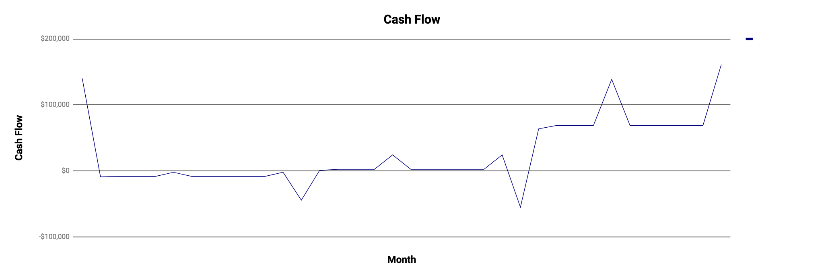

See Cash Flow Statement in the financial spreadsheet section.

## **Appendix C**

1. **Ownership specifics**

Michael Ding - Co-Director of Marketing

Alfred Xue - Co-Director of Marketing

Theo Liu - Co-Director of Finance

Erynn Lau - Co-Director of Finance

Mina Akbary - Production Manager

Elizabeth Dalton - Director of Design

Angelo Ilersich - Director of Design

Tiffany Huang - Director of Design

Kitty Li - Director of Communications

Maddi Richards- Director of Communications

1. **Role Description**

Department of Marketing: Find ways to convince consumers on the value of our product.

Department of Finance: Deals with the numbers and money earned and spent by the company.

Department of Production Management: Communicates with the producers of the product, makes sure everything is up to standard and keeps the company in order.

Department of Design: Designs and creates the overall outline and innovative ideas about the product.

Department of Communications: Works with the company's social media accounts, deals with the representation of the company, what the consumer sees and how we inform and get customers.

## **Appendix D**

**SWOT ANALYSIS**

|  |  |
| --- | --- |
| **STRENGTH** | **WEAKNESSES** |
| * Simple product * Easy to manufacture * Depth of training versus width | * Require long distance shipping * Not extremely long term durability * High price |
| **OPPORTUNITIES** | **THREATS** |
| * Expanding market * 21st century trends * Education towards Gen-Z about environmental sustainability | * Potential for defects * Potential for system collapse if one part of process fails * Trade disputes between Canada and where our manufacturer is based - China |

**PESTEL Environmental Analysis**

|  |  |
| --- | --- |
| **POLITICAL** | **ENVIRONMENTAL** |
| * political opposition towards pro-environment ideology * Growing trend of environmental conservatism led by the USA | * Depletion of materials that are used to create PET plastics |
| **SOCIAL** | **TECHNOLOGICAL** |
| * Potential for refusal to accept change to a new system | * Evolving AI technology and implementation of RFID |
| **ECONOMICAL** | **LEGAL** |
| * Growing income disparity between the different socio-economic classes around the world | * Legislation promoting phasing out and ban of all single-use plastics |

**Bibliography**

“10 Facts About Single-Use Plastic Bags.” *10 Facts About Single-Use Plastic Bags*, www.biologicaldiversity.org/programs/population_and_sustainability/sustainability/plastic_bag_facts.html.

Canadian Plastics Industry. “Bag Reduction Strategies - What Works.” *All About Bags*, www.allaboutbags.ca/reduction.html.

CredoBags. “Sustainable Fabrics.” *Credobags*, credobags.com/sustainable-fabrics/.ty

Griggs, Mary Beth. “Canada Plans to Ban Single-Use Plastics by 2021.” *The Verge*, The Verge, 10 June 2019, www.theverge.com/2019/6/10/18659644/canada-ban-single-use-plastics-bags-straws-2021.

Spacelist. “For Lease.” *Ottawa For Lease*, www.spacelist.ca/listings/77564/on/ottawa/for-lease/office/b1-1339_wellington_st_w.

The Globe and Mail. *Majority of Canadians Support a Ban on Single-Use Plastics: Poll*. 15 July 2019, www.theglobeandmail.com/politics/article-majority-of-canadians-support-a-ban-on-single-use-plastics-poll/.